Simplifying the ITLOS judgment
Ghana v Côte d'Ivoire maritime dispute

INTRODUCTION
The Special Chamber of the International Tribunal of the Law of the Sea (ITLOS) on September 23, 2017 delivered its judgment in respect of the maritime dispute between the Republic of Ghana (Ghana) and the Republic of Côte d'Ivoire (Côte d’Ivoire).

The dispute resulted in cessation of some petroleum activities in the T.E.N. fields in Ghana. Petroleum activities are however expected to resume following the ITLOS judgment.

Essentially a disagreement about the maritime boundary between the two countries and the difference in methodology in delimiting the boundary were the gravamen of the dispute between the two countries.

Whereas Ghana advocated an equidistant boundary methodology, starting from Boundary Pillar 55 (BP55), Côte d'Ivoire made the case for a sole maritime boundary which followed the 168,7-degree azimuth line from BP55.

PLOTTING THE COORDINATES
In applying an enthusiast’s approach to the coordinates of the boundary pillars, the various coordinates mentioned in the judgment were plotted on Google Earth. The results have been displayed in the images below. The coordinates submitted by Ghana have been plotted in yellow, coordinates by ITLOS in red and the 168.7 degree-line of Côte d'Ivoire shown in green.

The image below illustrates the difference between BP55 (denoted as CEB-1) and ITLOS BP55+.
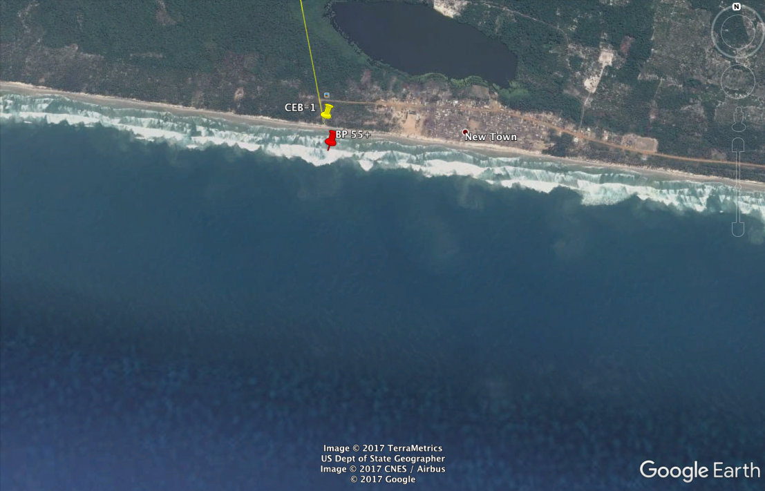

Plotting Ghana’s coordinates and those delivered by ITLOS show that there is not much difference between the coordinates submitted by Ghana and the judgment by ITLOS ( point F continues downwards 200 nautical miles from the coast line). The image below illustrates the point.
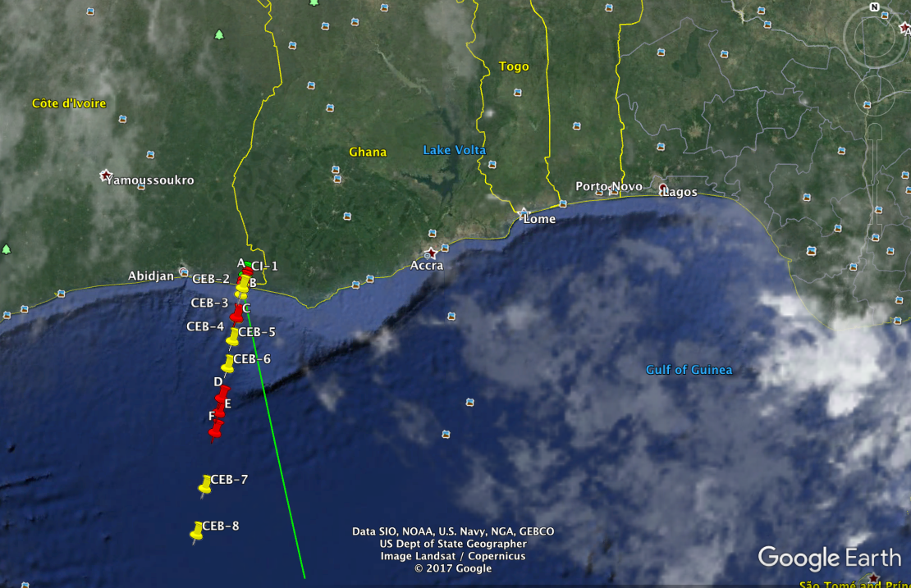

POTENTIAL LOSS
To demonstrate the potential loss Ghana would have suffered, a very simplistic overlay of an image of the T.E.N. field from the B&FT online has been inserted as an overlay on Google Earth. The overlay (see below) shows that had Côte d'Ivoire won, that is, if the 168.7 degree-line (in green) had been upheld, almost all of the T.E.N. fields would have gone to Côte d'Ivoire.
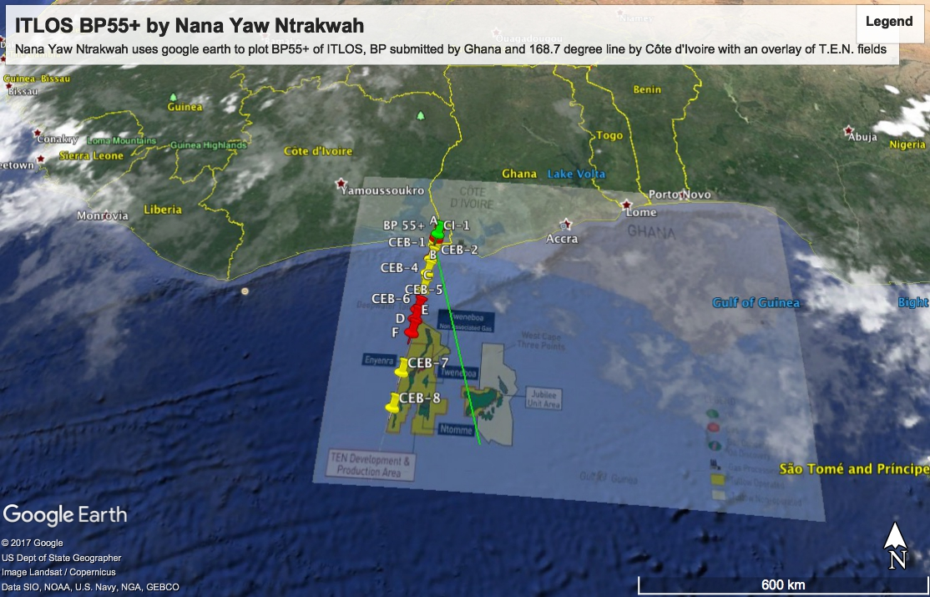

By this short article it is hoped that a clearer picture of the substance of the ITLOS judgment and the potential loss that could have occasioned Ghana has been provided.

Author:
Nana Yaw Ntrakwah
Partner, Ntrakwah and Co.
Dated in Accra the 23rd Day of September, 2017

Note: images were plotted by the author for educational purposes only.

